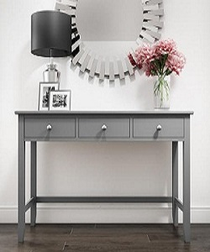

Table

$58.82

Availability: In stock

Description:

This simple table brings a bit of contemporary appeal to any ensemble in your home. While boxy sled-style base finish for an on-tred look. Three drawers for anything you want to keep. This fabulous design is perfect look for living room. Assembly is required.